**AMERICAN INTERNATIONAL UNIVERSITY–BANGLADESH (AIUB)**

**FACULTY OF ENGINEERING**

**DEPARTMENT OF EEE**

**DIGITAL LOGIC AND CIRCUITS LAB**

|  |
| --- |
| **Project Report name:** Brake Failure Indicator Circuit Using 555 IC  **Group Number: 02**  **Section:** Q **Semester:** Spring 2022-2023  **Course Teacher:** DR. TANBIR IBNE ANOWAR  **Subject Code:** EEE-3102 |

|  |  |  |
| --- | --- | --- |
| **Name** | **Student** **ID** | **Program** |
| Md. Omar Faruk Sakib | 21-45077-2 | CSE |
| Md. Abu Hojifa | 21-45081-2 | CSE |
| Ashfat Ahmed Medul | 21-44854-2 | CSE |
| Amina Tazin | 21-45141-2 | CSE |
| Md. Najib Hossain | 21-45366-2 | CSE |

**Group members**

**Brake Failure Indicator Using 555 IC**

**ABSTRACT:**

The 555 Timer is a highly stable integrated circuit that can produce accurate time delays and oscillations, and it can be found in many electronic devices. There are various sorts of circuits that generate various sounds. The objective of the experiment is to create a simple circuit using the 555 timer IC that produces a brake failure Indicator Sound, the intensity of which is dependent on the time till the brake is failed. Astable mode is used to operate the 555 timer IC with some external components to make the sound. This circuit can be activated by cut the bake wire, a tone with increasing intensity is produced. The intensity of the siren sound gradually decreases to zero once the brake wire is cut. This circuit can be used in designing brake failure indicator systems. The simulations of the brake failure indicator circuit will be done using Proteus online software.

**I. INTRODUCTION**

The 555 timer IC is an integrated circuit used in several oscillator, timer, pulse generation and delay applications. Due to its robust and steady characteristics, the IC 555 timer is one of the most often used ICs in electronics. There are three operational modes for the 555 Timer: bistable, monostable, and astable. The 555 timer is a dual in-line package (DIP) device with 8 pins. It has three identical 5k resistors in the voltage divider, two comparators, a flip-flop, a discharge transistor, and an output stage. It works as square-wave form generator with duty cycle varying from 50% to 100% and can also provide time delay in circuits. The 555 timer IC’s astable mode has been used in this project. When used in astable mode, the 555 timer oscillates and produces a square wave. By altering the values of two resistors and a capacitor connected to the chip, the frequency of the wave can be changed. In astable mode, the output cycles on and off continuously.

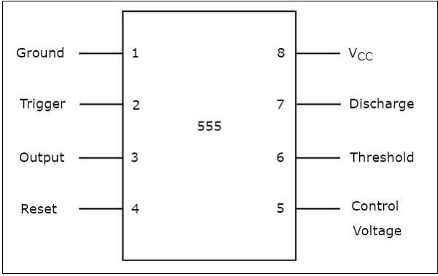

**Fig 1: Pin Diagram of 555 Timer IC**

The Brake Failure Indicator circuit is created by shorting IC pins 1,4 and 8 and connecting pin to ground. The supply voltage and pin 3 of the IC are connected via a PNP transistor acting as a switch. A 1k resistor and LED connects the base of this transistor. It can be seen that the IC is powered by a PNP transistor. Being a PNP transistor, it will be turned on by a negative voltage applied to the gate. The capacitor initially begins to charge through the 1k and 440k resistors when the supply is turned on. As a result of the capacitor being fully charged, there is a positive voltage at the transistor’s gate, which turns the transistor off. The capacitor discharges through the 1k resistor when the brake fails, creating a negative voltage at the transistor that activates it. Due to the length of time required for the capacitor to charge and discharge, this phenomenon produces an indicator siren.

**Fig 2: Brake Failure Indicator circuit**

**II. APPARATUS**

1. Breadboard
2. 555-timer IC
3. Resistors: 440K, 1k*2
4. Capacitors: 1uf, 0.1uf
5. Transistors: BC557
6. 9V battery
7. Buzzer
8. LED

**III. EXPERIMENTAL PROCEDURE**

1. At first, the circuit has been connected with a power supply of 9V.
2. Then we have made the connection of the IC 555 timer. We have connected pin 1 which is ground to negative terminal of the power supply.
3. We have shorted pin 2 and 6 and connected to ground via 1uF capacitor.
4. A PNP transistor (BC557) was connected as a switch between the supply voltage and pin 3 of the IC.
5. The pin no 4 is the reset pin that was connected to Vcc when not in use in order to avoid false triggering.
6. We have connected the base terminal of BC557 transistor to a 1K resistor and a LED is connected between its base terminals.

**IV. HARDWARE SETUP**

**Fig 3: Hardware circuit implementation**

**Fig 4: Hardware circuit of If brake wire is okay.**

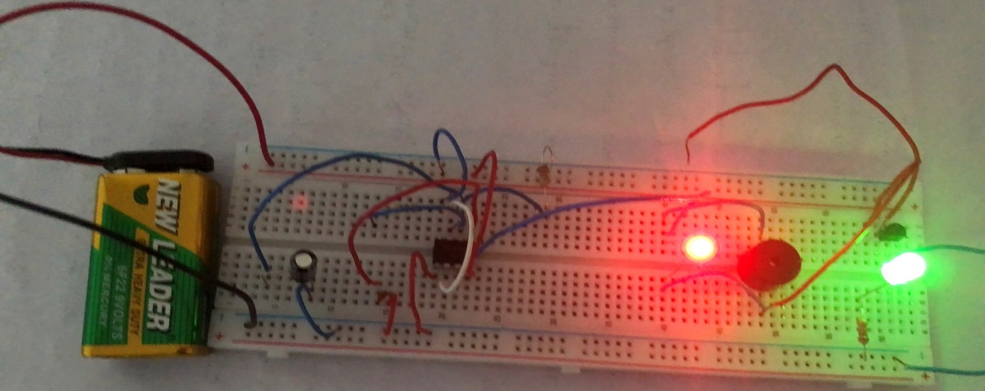

**Fig 5: Hardware circuit of If brake wire fails.**

**V. SIMULATION**

**Fig 6: Circuit implementation in Proteus.**

**VI. DISCUSSION AND CONCLUSION**

In this experiment, we have constructed a brake failure indicator sound. The circuit is built using 555 timer IC and some additional electronic components. The brake failure indicator sound is played on a buzzer. The 555 timer IC is an integrated circuit used in a variety of timer, pulse generation, and oscillator applications. It is a 3 pin IC and can be connected in two modes. In our circuit we have used it in astable mode to generate continuous square wave pulses. This circuit's central component is an astable setup that generates sound at a specific frequency. The 555 timer IC is powered by a PNP transistor. So that, the amount of current this transistor supplies to the 555 timer determines how loud the output sound will be. A PNP transistor's base pin will respond to negative voltage by allowing the maximum amount of current to flow through it, producing louder sound, and vice versa. With the help of a capacitor-resistor arrangement and this behavior, we were able to gradually increase and decrease the current flowing through the 555 timer IC while accounting for the length of time that the push button was pressed. As a result, the intensity of the indicator sound gradually rises before falling to silence. During the hardware implementation, the connections have been thoroughly checked when the circuit was built using the schematic diagram in figure 2. The breadboard circuit contains every component and connection depicted in the schematic in figure 2. The simulation of the experiment has been done using the online based software called Proteus. Finally, combining all the hardware and the software implementations it can be concluded that the experiment was successfully done.

**VII. REFERENCES**

1. AIUB Lab Manual
2. W.K. Lennon and K.M. Passino, "Intelligent control for brake systems," IEEE Transactions on Control Systems Technology, vol. 7, no. 2, pp. 188-202, 1999.